Session 9: Configuration Management and Supporting TCP/IP

9.1 Configuration Management

9.1.1 Definition: Configuration Management
Configuration management is a process for maintaining computer systems, servers, and software in a desired, consistent state. It’s a way to make sure that a system performs as it’s expected to as changes are made over time.

Managing IT system configurations involves defining a system's desired state—like server configuration—then building and maintaining those systems. Closely related to configuration assessments and drift analyses, configuration management uses both to identify systems to update, reconfigure, or patch.

9.1.2 Why Manage Configurations?
Configuration management—an important part of IT service management (ITSM)—keeps you from making small or large changes that go undocumented. Misconfigurations like these were identified in our State of Kubernetes Security report as a leading cause of security incidents among containerized or Kubernetes-orchestrated environments.

Misconfigurations can lead to poor performance, inconsistencies, or noncompliance and negatively impact business operations and security. When undocumented changes are made across many systems and applications, it adds to instability and downtime.

Manually identifying systems that require attention, determining remediation steps, prioritizing actions, and validating completion are too complicated to perform in large environments. But without documentation, maintenance, and a change control process, system administrators and software developers could end up not knowing what’s on a server or which software has been updated.

Configuration management systems let you consistently define system settings, as well as build and maintain those systems according to those baseline settings. Configuration management helps users and administrators know where certain services exist and what the current state of applications are.
Proper configuration management tools:
- Classify and manage systems by groups and subgroups.
- Centrally modify base configurations.
- Roll out new settings to all applicable systems.
- Automate system identification, patches, and updates
- Identify outdated, poor performing, and noncompliant configurations.
- Prioritize actions.
- Access and apply prescriptive remediation.

9.1.3 Configuration Management Benefits
Think of it like this. If you keep up with the small things, you can avoid more complicated, expensive repairs in the future. Configuration management is about preventing issues so you don’t have to deal with as many problems later.

For example, you can make sure that your test and production environments match. That way, you’ll have fewer problems with applications once they’ve been deployed than you would if these environments weren’t exactly the same.

With configuration management, you can accurately replicate an environment with the correct configurations and software because you know what exists in the original environment.

9.1.4 Automating Configuration Management
The role of configuration management is to maintain systems in a desired state. Traditionally, this was handled manually or with custom scripting by system administrators. Automation is the use of software to perform tasks, such as configuration management, in order to reduce cost, complexity, and errors.

Through automation, a configuration management tool can provision a new server within minutes with less room for error. You can also use automation to maintain a server in the desired state, such as your Standard Operating Environment (SOE), without the provisioning scripts needed previously.

9.1.6 Configuration Management Tools
Red Hat® Ansible® Automation Platform, when used as a configuration management tool, is used to store the current state of your systems and help you to maintain that state. Configuration management tools make changes and deployments faster, remove the potential for human error, while making system management predictable and scalable.

They also help you to keep track of the state of your resources, and keep you from repeating tasks, like installing the same package twice.

Improve system recovery after a critical event with automated configuration management. If a server goes down for an unknown reason, you can deploy a new one quickly and have a record of any changes or updates that occurred so you can identify the source of the problem.
Your configuration management tools can also help you to run an audit of your system so you can more quickly identify where the problem is coming from.

9.2 Introduction to TCP/IP
Transmission Control Protocol/Internet Protocol (TCP/IP) for Microsoft® Windows® XP Professional offers a standard, routable enterprise networking protocol that is the most complete and accepted protocol available. Most network operating systems in use today offer TCP/IP support, and large networks rely on TCP/IP for much or all of their network traffic.

The various protocols in the TCP/IP stack function together to make network communication happen. The communication process involves multiple activities, including resolving user-friendly computer names to Internet Protocol (IP) addresses; determining the location of the destination computer; and packaging, addressing, and routing the data so that it reaches the destination successfully.

To effectively manage and support Windows XP Professional in a network environment, you need to understand the TCP/IP communication process, how IP addresses are assigned, and how to use TCP/IP utilities to troubleshoot communication problems.

TCP/IP uses a layered communication model to transmit data. This model is comprised of a set of protocols that are layered upon each other. Each layer of protocols provides a specific function and service in transmitting data.
Understanding the overall network communication flow and the function of the protocols in the communication process can assist you with both configuration and troubleshooting activities.

9.3 Network Communication
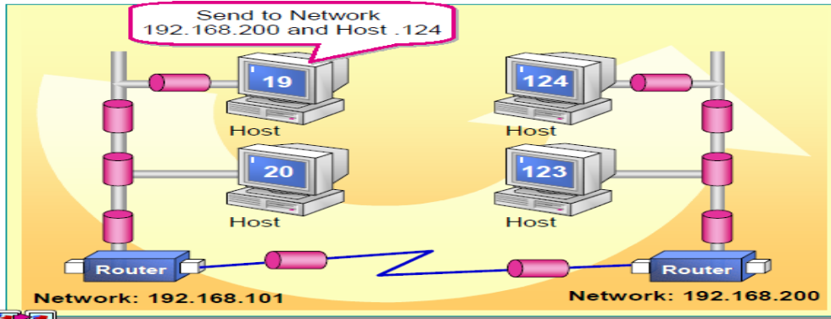

The process by which TCP/IP transmits data between two locations is analogous to someone creating and sending a letter from one city to someone in another city. The TCP/IP communication process is initiated by using an application on the source computer that prepares the data to be transmitted in a format that an application on the destination computer can read. This process is similar to writing a letter in a language that the recipient can understand. The data is then associated with the destination application and computer, similar to how you address a letter to a recipient and household. The address of the destination computer is then added to the data, just as the address of the recipient is specified on the letter.

Each TCP/IP host is identified by an IP address. A unique IP address is required for each host that communicates by using TCP/IP. The IP address identifies a system’s location on the network in the same way a street address identifies a house on a city block. Just as a street address must identify a unique residence, an IP address must be globally unique and have a uniform format.

The TCP/IP communication process is initiated using an application on the source computer that prepares the data to be transmitted. The address of the destination computer is then added to the data. The data and destination address are sent over the network to the destination. The network medium used for transmitting the data is independent of the activities that are directly related to creating the data.
In a network, many applications use network resources at the same time.

Furthermore, the network may contain many devices. TCP/IP employs a method for differentiating protocols from one another and uniquely identifying each device on the network. Adhering to these addressing standards is important for a fully functioning TCP/IP network.

9.4 TCP/IP Protocol Suite
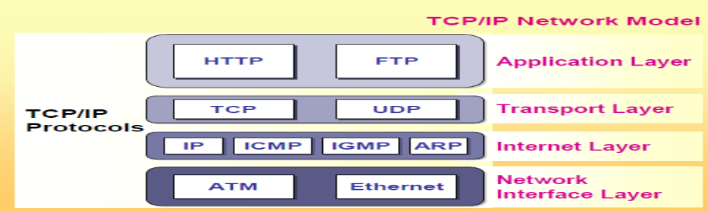

The tasks that are involved in using TCP/IP in the communication process are distributed between protocols that are organized into four distinct layers of the TCP/IP stack. The four layers are application, transport, Internet, and network interface. All protocols that belong to the TCP/IP protocol stack are located in these four layers of the model.

Application Layer
The application layer is the topmost layer in the TCP/IP stack. All applications and utilities are contained in this layer and use this layer to gain access to the network. The protocols in this layer are used for the formatting and exchange of user information. The following are some examples of protocols that exist within the application layer:
- Hypertext Transfer Protocol (HTTP)
HTTP is used to establish a connection with a Web server and transmit Hypertext Markup Language (HTML) pages to the World Wide Web.
- File Transfer Protocol (FTP)
FTP is used to transfer files over a TCP/IP network; for example, after developing the HTML pages for a Web site on a local computer, the pages are typically uploaded to a Web server by using FTP.

Transport Layer
The transport layer provides the ability to gain and guarantee communication between computers, and passes the data up to the application layer or down to the Internet layer depending on whether the data is being sent or received. The transport layer also specifies the unique identifier of the application to which data is to be delivered. The transport layer has two core protocols that control the method by which data is delivered:

- Transmission Control Protocol (TCP)
TCP is a reliable, connection-oriented delivery service. Connection-oriented means that a session must be established before hosts can exchange data.
Reliability is achieved by assigning a sequence number to each segment of data transmitted. If a TCP segment is broken into smaller pieces, the receiving host knows whether all pieces have been received. An acknowledgment is used to verify that the other host received the data. For each segment sent, the receiving host must return an acknowledgment (ACK) within a specified period, for the segment that is received.

- User Datagram Protocol (UDP)
UDP provides fast delivery of data, but does not guarantee data delivery. UDP provides a connectionless service that offers unreliable, “best effort” delivery. This means that the arrival of data is not guaranteed, nor is the correct sequencing of delivered segment of data. UDP is used by applications that do not require an acknowledgment of receipt of data and that typically transmit small amounts of data at one time. Reliability becomes the responsibility of the application.

Internet Layer
The Internet layer is responsible for addressing, packaging, and routing the data that is to be transmitted. This layer contains four core protocols:

- Internet Protocol (IP)
IP is responsible for addressing the data that is to be transmitted and transmitting the data to its destination.

- Address Resolution Protocol (ARP)
ARP is responsible for identifying the media access control address of the network adapter on the destination computer. The media access control address is a unique 12-character hexadecimal number, such as B5-50-04-22-D4-65, for a physical device such as the network adapter.

- Internet Control Message Protocol (ICMP)
ICMP is responsible for providing diagnostic functions and reporting errors that result from the unsuccessful delivery of data.

- Internet Group Management Protocol (IGMP)
IGMP is responsible for the management of multicasting within TCP/IP. Multicasting is the process of sending a message simultaneously to more than one destination host on a network.

Network Interface Layer
The network interface layer is responsible for merging data on the network medium and receiving data that resides on the network medium. The network interface layer contains protocols such as Ethernet and asynchronous transfer mode (ATM), which define how data is transmitted on the network.

9.5 TCP/IP Communication
TCP/IP transmits data on the network by dividing it into smaller portions called packets. As the data packets pass through each layer, the protocol in that layer attaches information, referred to as a header. The header contains instructions used to transport the data to the specified destination. When sending packets from the source, the data and header are encapsulated and treated as data by the protocol in the layer below.

When the packet is received at the destination, the corresponding layer strips off a header and treats the remaining packet as data. For example, the header added by the transport layer on the originating computer is examined, used, and removed by the transport layer at the destination computer. The packet is then passed up the protocol stack to the next appropriate protocol until it reaches the destination computer.

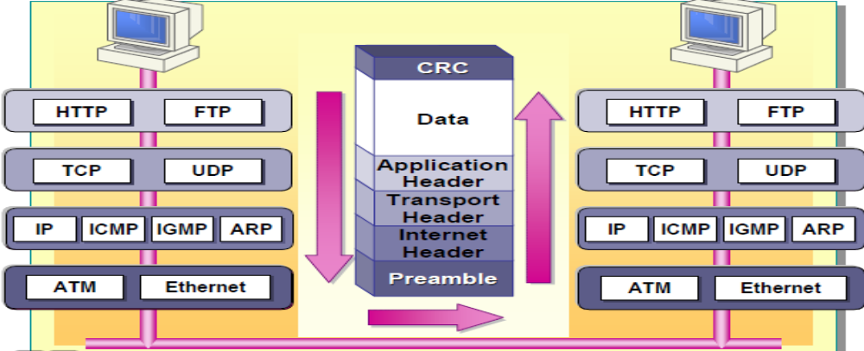
Figure : Data flow within a TCP/IP network

Application Layer
The data transmission process begins at the application layer of the TCP/IP protocol stack. An application, such as the FTP utility, initiates the process at the source computer by preparing the data in a format that the application at the destination computer recognizes. The application at the source computer controls the entire process.

Transport Layer
From the application layer, the data moves to the transport layer. This layer contains the TCP and UDP protocols. The application initiating the transmission request selects which protocol to use, for example TCP, and the checksum is added. A checksum is a numerical value that is used to test the data to ensure the transport was free from errors.

When TCP is used, it:
- Assigns a sequence number to each segment to be transmitted.
- Adds acknowledgement information for a connection-oriented transmission.
- Adds the TCP port number for the source and destination applications.

Internet Layer
After the transport information is added, the data packet is passed to the Internet layer of the TCP/IP protocol stack. In this layer, IP adds the following information:
- The source IP address
- The destination IP address
- The transport protocol
- A checksum value
- Time to Live (TTL) information

In addition to adding this information, the Internet layer is also responsible for resolving the destination IP addresses to a media access control address. The media access control address is added to the packet header and the packet is handed down to the network interface layer.

Network Interface Layer
At the network interface layer, two types of information are added: a preamble and a cyclical redundancy check (CRC). The preamble is a sequence of bytes that identifies the beginning of a packet. The CRC is a mathematical computation that is added to the end of the packet to verify that the packet has not been corrupted.
After the information is added to the frames at the network interface layer, they are merged onto the network.

9.6 Destination Computer
When the frames reach the destination computer, the network interface layer on this computer discards the preamble and recalculates the CRC. If this value matches the value calculated before transmission, then the destination media access control address on the frame is examined.

If the media access control address is a broadcast address or if the media access control address matches that of the destination computer, the frame is passed to the IP in the Internet layer above, otherwise the frame is discarded. At the IP layer, IP recalculates the checksum and compares it with the value calculated before transmission to determine if the packet arrived intact. Then IP passes the packet to the transport protocol identified in the IP header.

At the transport layer, if the packet is received by TCP, it checks the sequence number on the packet and sends an acknowledgement back to TCP at the source computer. Then, sends it onwards to the appropriate application in the application layer above. After the application receives the data, it processes it as required.

9.7 Examining Classful IP Addressing
To communicate on a network, each computer must have a unique IP address and conform to a standard format. The IP address identifies a computer’s location on the network. Understanding the IP address format and standards is necessary when assigning and troubleshooting IP addresses.

9.8 IP Address Components
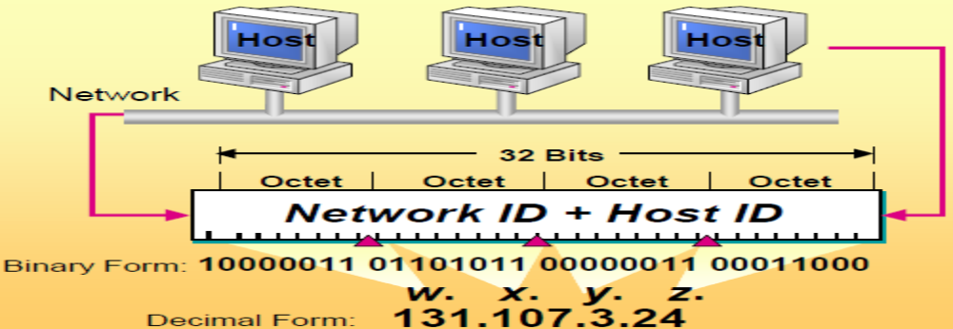

An IP address has two parts: the network ID and the host ID.

Network ID
The first part of the IP address is the network ID, which identifies the network on which the computer is located. All computers on the same network must share the same network ID.

Host ID
The second part of the IP address is the host ID, which identifies a computer, router, or other device within a network. The host ID for each host must be unique within the network ID.

Each IP address is 32 bits long and is composed of four 8-bit fields, called octets. Octets are separated by periods.

Binary notation is ideal for IP addressing because it contains only two symbols which can represent the two states of a bit: on or off. However, binary notation is awkward when communicating with others (“Your IP address is 11101001 11101111.etc.”), and prone to input errors. Therefore, binary notation is converted into its decimal value. The octet represents a decimal number in the range 0–255. This format is called dotted decimal notation. The following table gives an example of an IP address in binary and dotted decimal formats.

Binary format Dotted decimal notation
10000011 01101011 00000011 00011000 131.107.3.24

Binary to Decimal Notation



Knowing how to translate decimal to binary and binary to decimal is useful in deciphering an IP address. When using decimal notation, there are ten symbols available: 0 through 9. Each decimal number has a positional value expressed as 10^{x} power.
The principles of binary notation are the same as decimal, except that you are working with two symbols: 0 and 1, and each position in the number is 2 x in value. A bit that is set to 0 always has a zero value. A bit that is set to 1 can be converted to a decimal value.

The low-order bit, or the rightmost bit, represents a decimal value of one. The high-order bit, or the leftmost bit, represents a decimal value of 128. The highest decimal value of an octet is 255—that is, when all bits are set to 1.
The following table shows how the bits in one octet are converted from binary code to a decimal value.

Binary code | Bit values | Decimal value
00000000  00000001  00000011  00000111  00001111  00011111  00111111  01111111  11111111 | 0  1  2+1  4+2+1  8+4+2+1  16+8+4+2+1  32+16+8+4+2+1  64+32+16+8+4+2+1  128+64+32+16+8+4+2+1 | 0  1  3  7  15  31  63  127  255

Practice
1. Convert the following binary numbers to decimal format.
10001011
10101010
10111111 11100000 00000111 10000001
01111111 00000000 00000000 00000001

2. Convert the following decimal values to binary format.

250
19
109.128.255.254
131.107.2.89

9.10 Address Classes
Because each IP address must be unique, IP addresses were initially distributed in groups or classes from a centralized organization called InterNIC. The classes were divided into several major groups based on size, in terms of the number of hosts per network. The value of the first octet determines which class the IP address belongs to.
The size of your network determines the IP address class. You need to obtain enough IP addresses for each device on your network, including computers, printers, and other accessible devices. Because each IP address is made up of 32 bits, by using one octet for the network ID and the remaining three octets for the host IDs, you can have numerous hosts (16,777,214 or 224 minus 2 addresses, one for a broadcast addresses and one for a default route) associated for a single network ID.

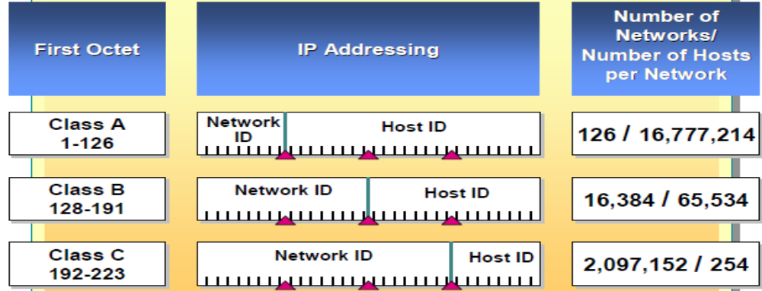

The following table describes the different IP address classes.

Classes | Description
Class A | These addresses are assigned to networks with a very large number of hosts. This class allows for 126 networks, because it uses the first number for the network ID. The remaining three octets are used for the host ID, allowing for 16,777,214 hosts per network.
Class B | These addresses are assigned to networks that range from medium to large in size. This class allows for 16,382 networks, because it uses the first two octets for the network ID. The remaining two octets are used for the host ID, allowing for 65,534 hosts per network.
Class C | These addresses are used for small, local area networks (LANs). This class allows for approximately 2,097,152 networks, because it uses the first three octets for the network ID. The remaining octet is used for the host ID, allowing for 254 hosts per network.
Classes D and E | These are not allocated to hosts. Class D addresses are used for multicasting, and class E addresses are not available to users for general use. The first octet in a Class D address ranges from 224 to 239, and for a Class E address it is 240-255.

